An accompaniment to the family of vines

LAGIVA VINERY WINES

LAGIVA VINERY wine BOOK

AN INTRODUCTION TO WINE AND SPIRITS

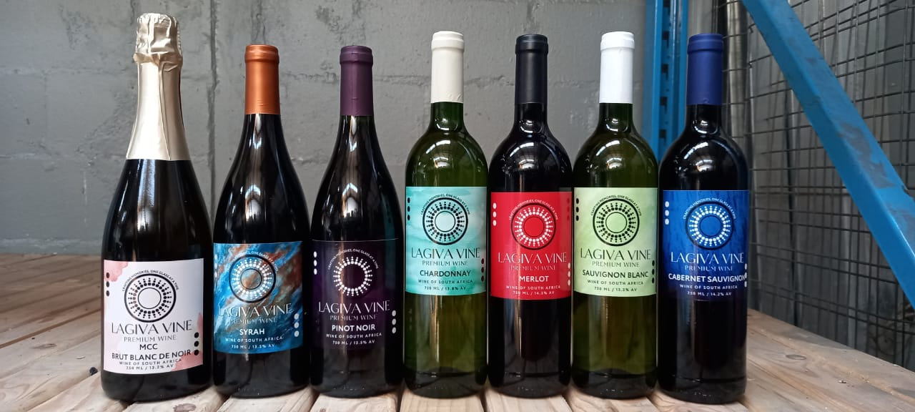

With its deep ruby rue, this exquisite wine

Invites you to savor its rich bouquet of ripe cherries, soft plums, and subtles hints of vanilla.

Each sip reveals a velvety texture, blending luscious fruit notes with delicate spices and a touch of oak, culminating in a smooth,

Lingering finish.

Perfectly balanced, our merlot is an ideal companion to a wide range of dishes, enhancing every occasion with its refined character.

AN INTRODUCTION TO WINE AND SPIRITS

An accompaniment to the family of vines

LAGIVA VINERY WINES

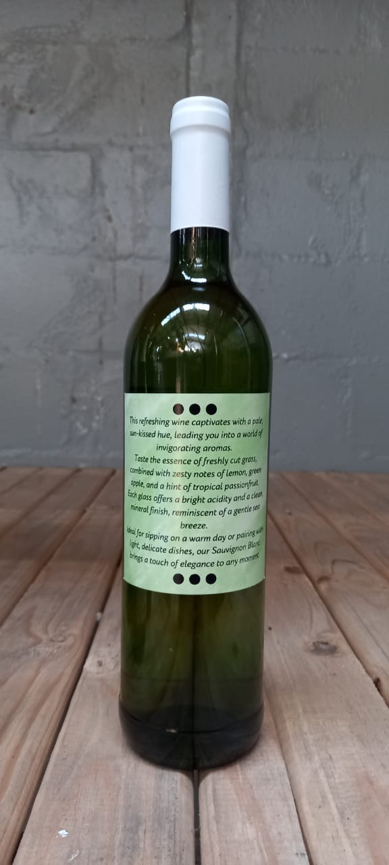

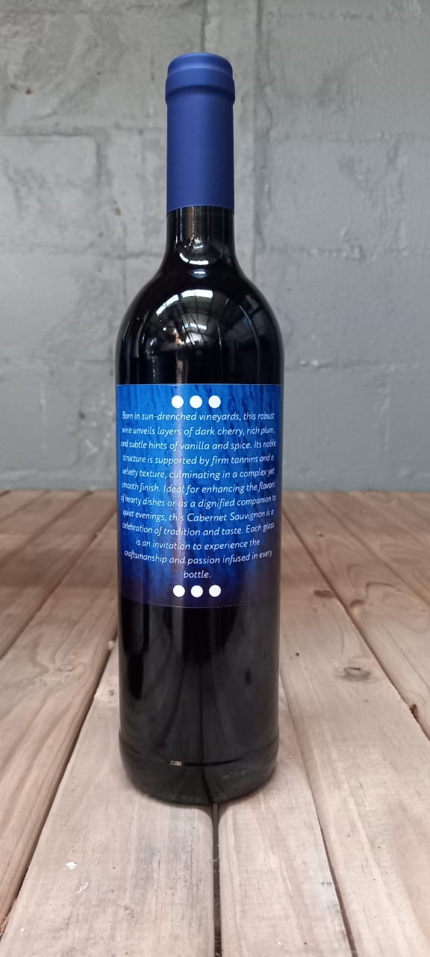

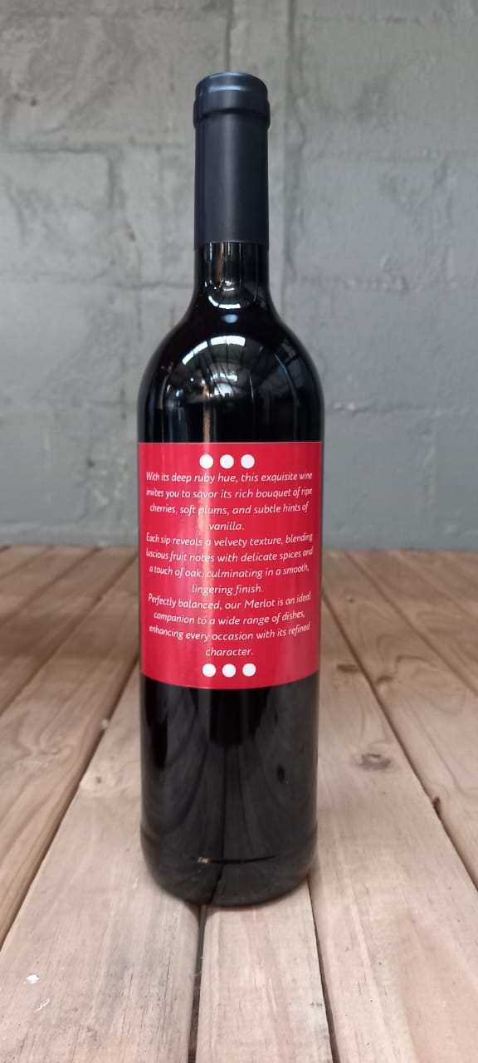

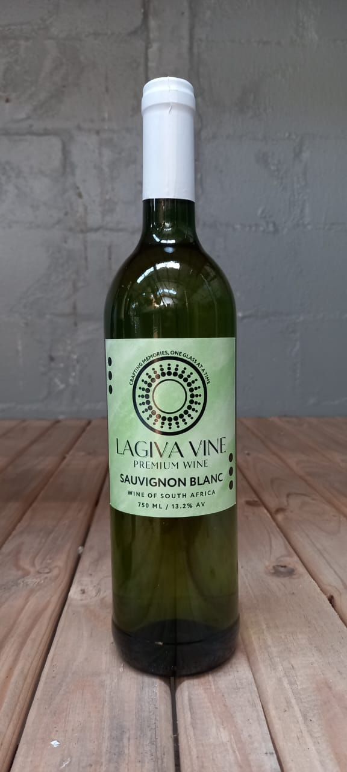

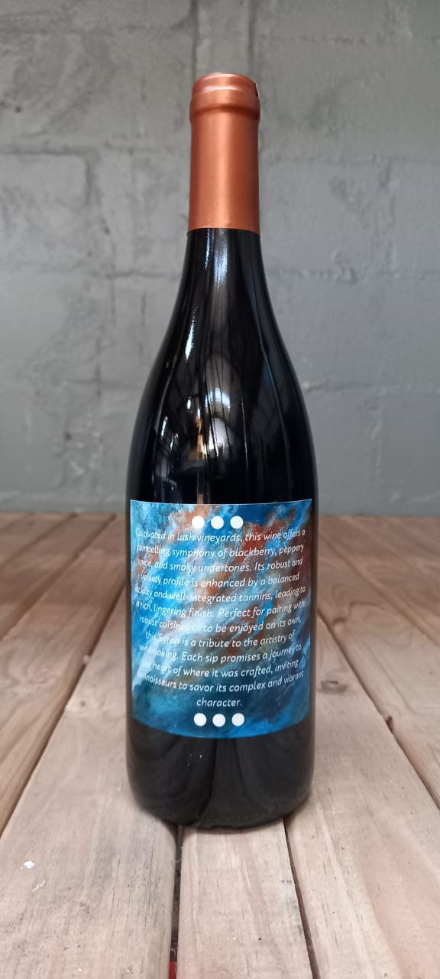

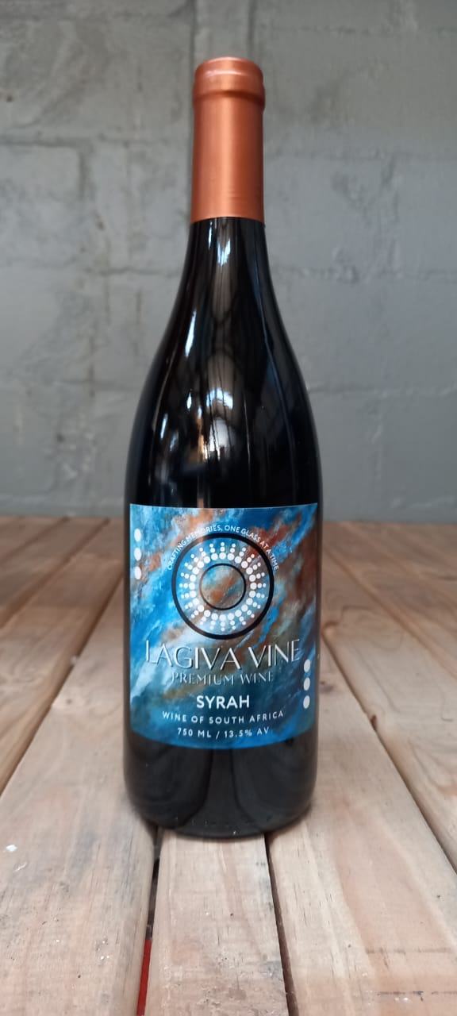

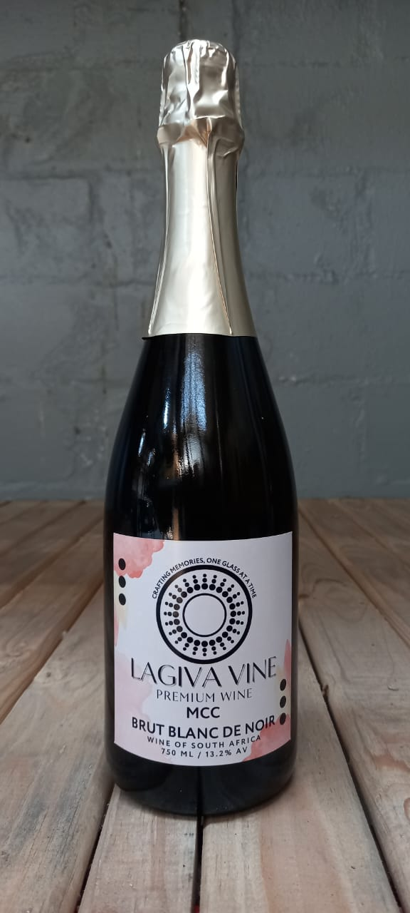

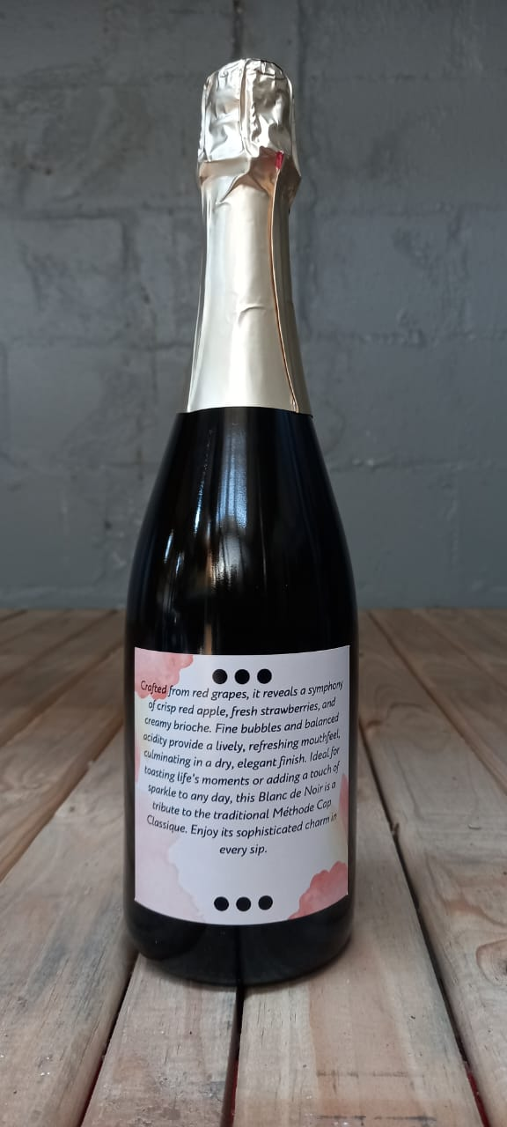



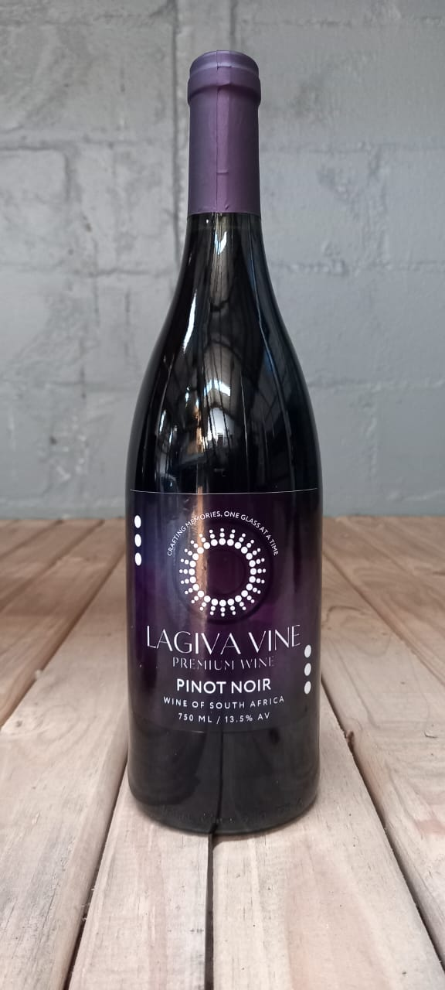

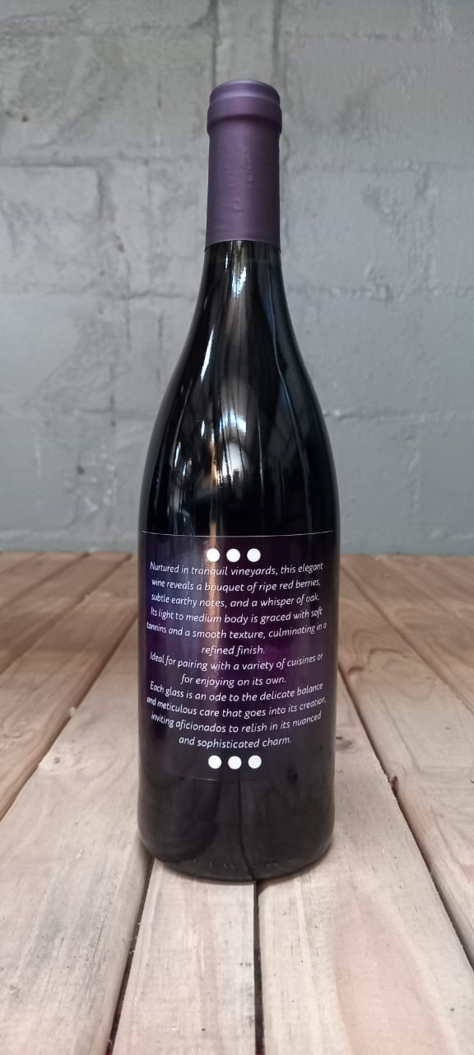

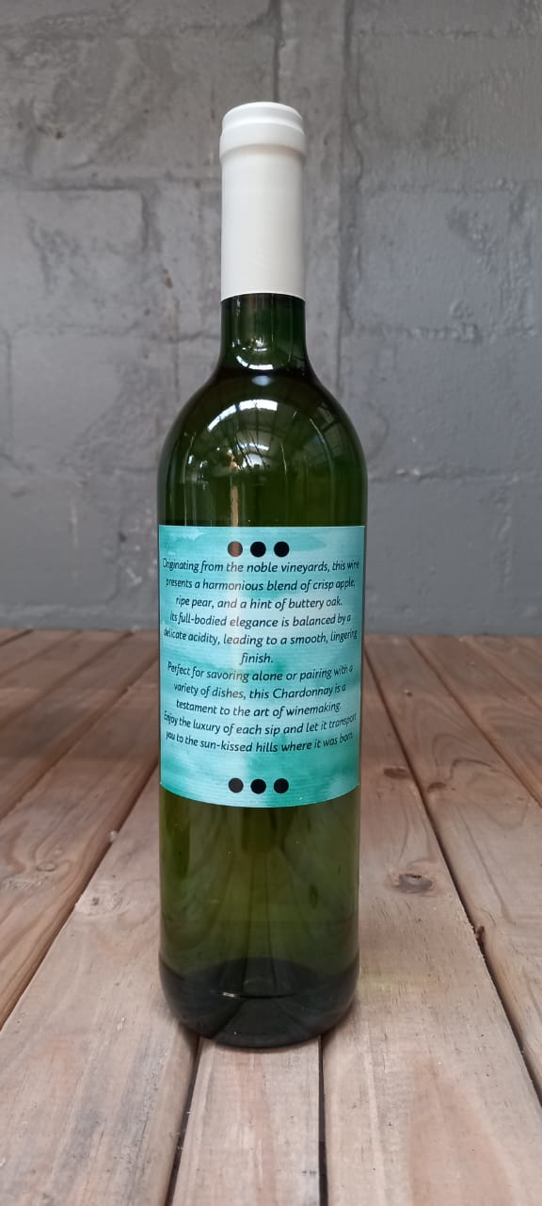

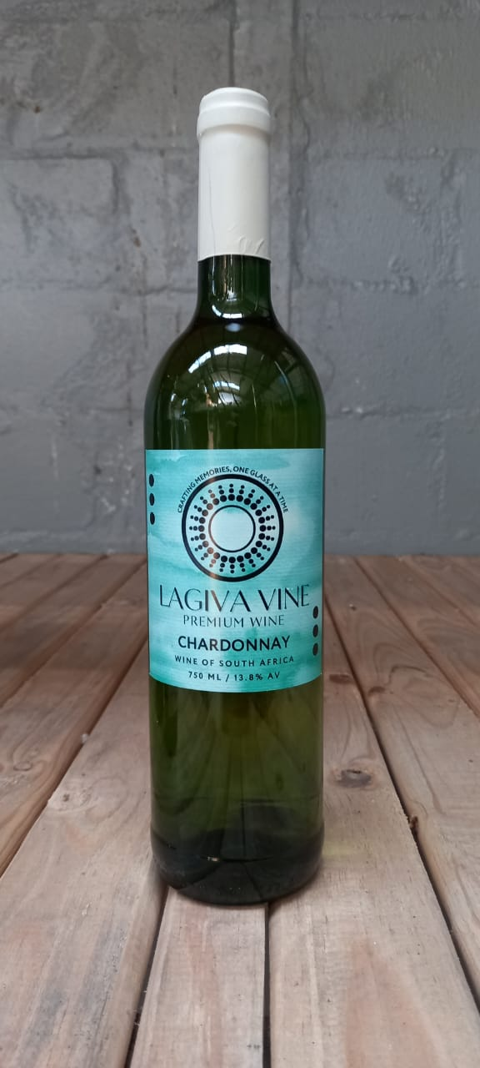

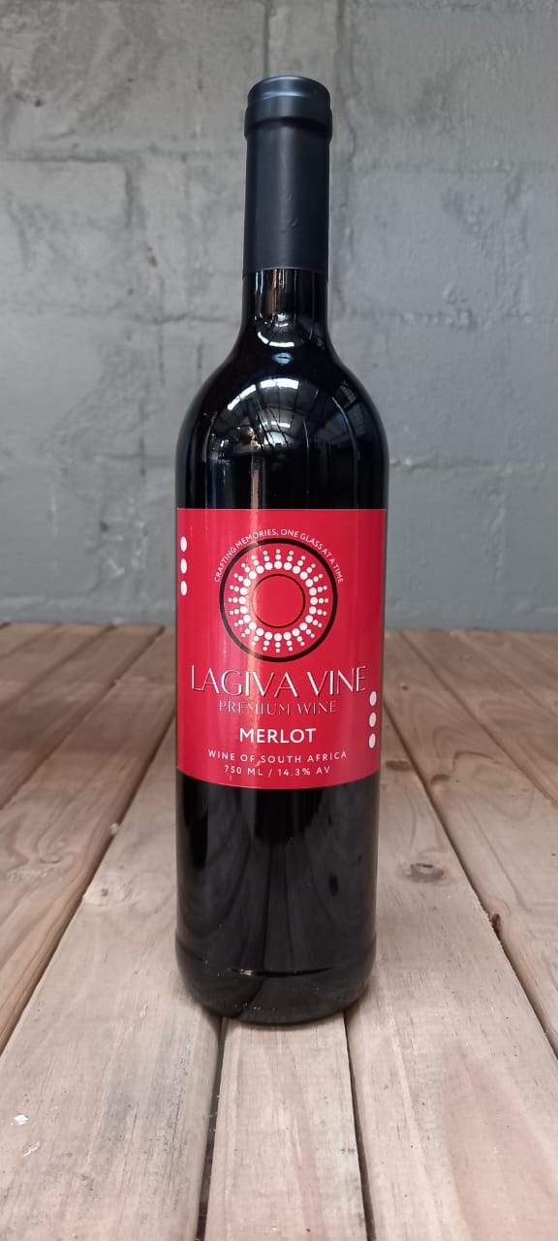

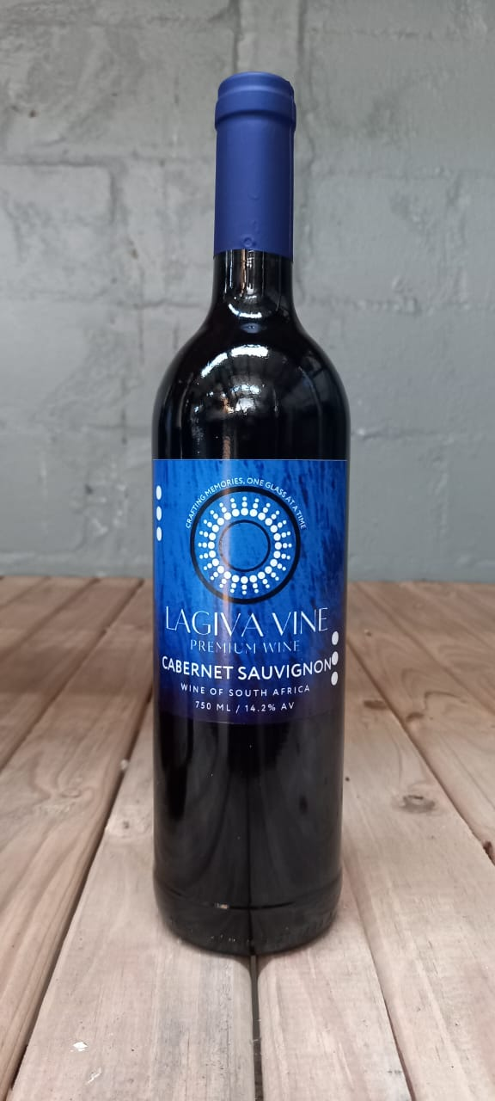

**Content**

***Introduction***

**1 what is wine?**

**2 Growing Grapes**

**3 Making Wines**

**4 Type and Style of Wine**

**5 Principal Grape Varieties**

**6 Examples of Wines**

***Wine List Exercise***

**7 Storage and service of wine**

**8 An introduction of Tasting**

***Tasting Notes***

**9** **Pairing Wine and Food**

***Food and Wine Interactions***

***Food and Wine Pairing Exercise***

***Introduction***

Welcome to the LAGIVA VINERY WINES, a one-day wine will never ruin your taste, mostly crafting memories, one glass at the time. For those studying wine for the first time, or wine drinkers for the first time yes indeed first sip will be wild but trust me, it gets better as time goes by together with your umami and acidic part develops to master all the tasting buts of vine through, attending various wine tasting events mostly indulging into various types of “LAGIVA” wine range calibres.

The world of wine can be very daunting, so how do you know what the differences are between wines, that’s when “LAGIVA De Chef” will intrude by introducing or taking you to the journey of being a wine fanatics likewise, he said “*CRAFTING MEMORIES, ONE GLASS AT THE TIME”* meaning while having your glass with full of lavish understanding of being a wine fanatic with times one step at the time like crawling with each and every moment per sip in your mind.

You will be introduced to the main wines styles, principal grape varieties also pairing food with wines and other examples of wine. Our LAGIVA vinery wine range is as follows: RB MERLOT, RB SAUVIGNON BLANC, RB CHARDONNAY, RB CABERNET SAUVIGNO, RB CABERNET ROSE, COFFEE PINOTAGE 2021, SWEET RED, SWEET ROSE, CABERNET PINOTAGE 2021, SYRAH 2016, MCC BRUT BLANC DE NOIR, and PINOT NOIR. This enables you to read many wines labels and allows you to know what to expect from the wines inside the bottle.

We hope you enjoy the enthusiasm of being a wine fanatic as well and in the future you will reap the benefits of your enhanced knowledge from joining our world of vines and wines best-known as one of our culture at LAGIVA VINERY WINES. Simply looking to enjoy a good glass of wine think about nothing but crafting memories, one glass at the time that’s LAGIVA VINE FOR YOU.

**CHASING THE DREAM OF A WINE FANATIC**

**OH** Who is a wine fanatic in the family? The one and only “Gift Nkaxa Nyoni” oh are you not an alcoholic Gift? We thought that maybe you don’t drink alcohol or are you maybe?

Wow guys let me bring this in two piece being a wine fanatic is always about alcohol it is usually norm or a culture of being a fan or being obsessed with consuming various types of wines and indulging mostly in the culture of vines and having knowledge of what you a drinking, mostly reading your thought of the virtue that comes with thee maturity of being a wine fanatics. It is not always about the alcohol but it is more literally about engaging and emerging the relations of understanding the type of beverage wine consumption is and knowing the most benefits of wine within your body and health. Reason being it is true wine consumptions has levels I mean we all know crafting memories, one glass at the time brings healthier lifestyle due to besides being one of the most alcohol abuser.

Is not that a fancy life Gift?

Not at all we have varieties of wines some are alcoholic and non-alcoholic obvious prices will differ.

There might be a calibre of the culture will determine you according to standard of which brand are you consuming mostly as your wine range and the most tip is knowing the range of wines based on how they differ according to brewing and maturing of years. That’s one of the most interesting part of being a wine fanatic. Within our Black community, it was a shock to them when they noticed that how very profound and deep I am about wines. Usually some says it is very rare to find a young optimistic young boy from non-grape farm around nor wines companies around his province best- known as “GAUTENG”.

What is the purpose of wine Gift?

Top notch, the purpose of wine is to bring people together like families, friends, colleagues, siblings, neighbours or communities during their beloved celebrations likes weddings, parties, anniversaries, dates nights, lunches, graduations and meetings. Some hosts celebrity events, one of the most notable part for wine brewers is to bring happiness to clients with full of bubbly occasions due to different seasonal times. A simple recipe of a wine is noticed by the way they express their feelings when they hold wine glasses before crafting memories with the first sip likewise when you know you know thee usual way we shake our glasses up high till to the hip of our nose allowing the breeze of various aroma from the wine to explore our taste buds. A simply norm of using different glasses for wines and champagne for a reason after all.

What was your dream when chasing the wine industry Gift?

Well-spoken salute to that, it has always been a dream to me that one of the good days I can live in the world of wines. There some says lagiva like saying it will be possible only if he believe that he can make it like those who made it to be one of the youngest well-known wine master in the industry amongst other wine brewing master. Wow indeed it was all in action since from the day my company was in practical “LAGIVA VINERY WINES”. THIS IS WHO I WAS BEFORE CHASING THE DREAM OF A WINE FANATIC TO BEING A WINE COMPANY OWNER. I am a big fan of grapes since from an early age, therefore my late taught me about various types of beverages and even how to manage their classy behaviour while you are intoxicated or having fun that is one of the first rule of having beverage consumptions of alcohol level in your body system.

THIS IS MY STORY OF WINES

*SIGNATURE (SPACE)*

GIFT NKAXA NYONI

FOUNDER, LAGIVA VINERY

Details

*PHYSICAL ADDRESS*

LAGIVA VINERY

6880 BLOCK F4

NEW EERSTERUS

HAMMANSKRAAL

GAUTENG

0400

*SOCIAL MEDIA CONTACTS*

CALL: +27 (0) 81 449 8919

EMAIL: [info@lagivavinery.co.za](mailto:info@lagivavinery.co.za)

WEBSITE: [www.lagivavinery.co.za](http://www.lagivavinery.co.za)

*SOCIAL MEDIA PAGES*

FB: Lagiva Vinery

Twitter: /Lagiva Vinery

Insta: /Lagiva Vinery

**1 what is wine?**

Wine is fermented grape juice, usually wine has various reasons when we consume it some is for celebration and occasions or events within the households. There are certain ingredients that are used for the flavours within our wines such as apples, lemons, peach, pineapple, asparagus, green bell pepper (green pepper), pear, floral, lime, blackcurrant, mint, vanilla (oak), plum, blackberry, strawberry, Red cherry, black pepper.

**Parts of a Grape**

There are two principal types of grapes: white grapes and black grape. On the inside, these grapes look very similar. The keys difference between them is that black grapes have deeply coloured skin that also contains tannins. Therefore white are higher in containing acidic taste mostly.

GRAPE SKINS

“This is a black grape, which has deeply coloured skin.

The skin also contains tannins, which can make your

Mouth feel dry.

The skin of white grapes has a golden colour”.

PULP

“The pulp of a grape is soft and fleshly. The colour of the pulp is the same regardless of the colour of the grape skin.

The pulp contains the grape juice, which is mostly made up of water, sugar and acid.

**ALCOHOLOLIC FERMENTATION**

Mostly alcohol fermentation to take place, needs certain main ingredients such sugar and yeast which are required. What are the yeast within the wine fermentation, yeast are microscopic organisms that eat sugar and convert it into alcohol and carbon dioxide gas. In most cases the use of yeast have eaten all of the sugar and the alcohol beverage consist of human body capacity. Newly made wine within the fermentation carbon dioxide escapes into the atmosphere.

Sugar + yeast alcoholic Alcohol + Carbon dioxide

Fermentation

b